Drawing I Course Materials

Drawing Essentials, 3rd Edition Required Deborah Rockman Retail $80.00
Drawing from Observation by Curtis Recommended
Purchase through Valencia West Bookstore or Valencia/UCF DTC Bookstore
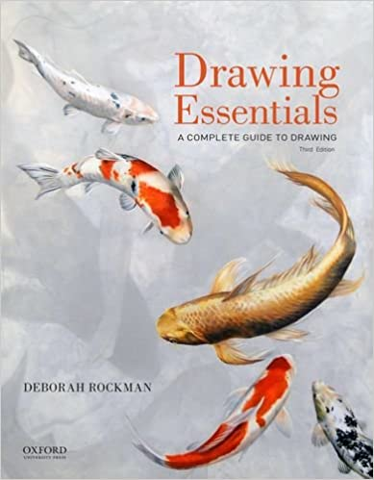

Your required text for the course is Drawing Essentials which is available at the bookstore, will help you build the specialized art vocabulary we will use in the production and review of your drawings. This text has over 55 historical and contemporary drawing reproductions that will enrich your understanding of drawing as a means of communication. t’s art historical and cultural significance. Fine art has its own language, just as any discipline does, and in order to understand or be understood by one another as we talk about your work, we need to have a mutual understanding of this language. Assigned readings from the text will reinforce your understanding of this vocabulary.

ART SUPPLIES - REQUIRED
- 18”x 24” Newsprint pad with rough paper
- 11” x 14” Sketch Book
- 8 Sheets White Drawing Paper (Keep in Newsprint Pad to protect
- 2 Sheets Mixed Media 18” x 24 “ Paper
- 1 sheet 12” x 18” Grayscale Paper
- 5 Thin Sticks Vine Charcoal
- 1 Large Stick Vine Charcoal
- 1 Stick Compressed Charcoal
- 1 Charcoal Pencil 4 B or 6 B
- 1 Charcoal Pencil White
- Pencil sharpener or Exacto knife with # 11 blades Recommended for sharpening
- Vinyl Eraser
- 1 Kneaded Eraser
- Graphite Pencil Set including B, 2B, 4B, 6B
- Chamois Cloth
- Blending Stump
- Speedball Ink
- 1-FM # 8 Round Brush

Optional
• 2 Bulldog clips – huge binder clips that secure drawing paper to board
• Drawing board larger than paper 24 x 36 inch
• Ruler 18”-24” or cardboard straight edge • Colored Pencils
- Felt-tip or Gel pens – assortment
- Blue Painters Tape Spotlight – You will need a source of light later this semester that you will use to create shadows and organized your light values.
WORKSPACE
You need to set up a workspace in your room to work. If you do not have an easel, you can prop your drawing board on a chair. It is best to stand while draw standing. As a student, I paced a table against a wall and then placed a chair on top that I leaned my pad against. Be creative!

WHERE TO SHOP
ARTSYSTEMS 1740 Semoran Rd. (FL 436) Winter Park, FL 32792 407-679-4700-student discount w/ school ID Call for store hours during COVID-19
SAM FLAX 1800 E. Colonial Dr. Orlando, FL 32803. 407-898-9785 - student discount w/ school ID Call for store hours during COVID-19
Dick Blick Art Supply 1(800)426-6740 www.blick.com
Valencia Bookstore Online Student Financial Aid can be applied for purchases.
$10 shipping – Check out the new and improved online store for art supplies.

